MTH501 Assignment Fall 2024. By Pin✌ And Muhammad.

Section: Saima Shafi .

Question ❓

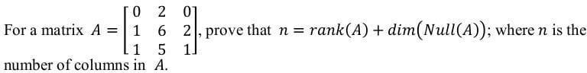

Solution.

To prove the equation

n = rank(A) + dim (Null(A)), we need to understand the concepts involved.

1. Rank of a matrix: The rank of a matrix is the maximum number of linearly independent rows or columns in the matrix. It represents the dimension of the vector space spanned by the rows or columns of the matrix.
2. Null space of a matrix: The null space of a matrix, denoted as Null(A), is the set of all vectors that, when multiplied by the matrix, result in the zero vector. In other words, it is the set of solutions to the homogeneous equation Ax = 0 .

Now, let's prove the equation

n = rank (A) + dim {Null (A) for the given matrix A.

Step 1: Find the rank of matrix A.

To 1nd the rank of matrix A , we can perform row operations to reduce the matrix to its row-echelon form or reduced row-echelon form. The number of non-zero rows in the row-echelon form or reduced row-echelon form will give us the rank of the matrix.

Performing row operations on matrix A , we can reduce it to row-echelon form:

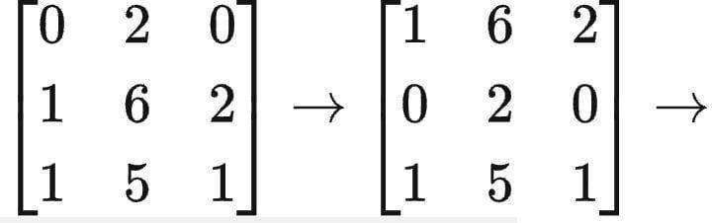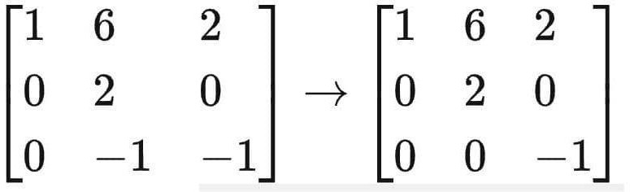

The row-echelon form of matrix A has three non-zero rows, so the rank of matrix A is 3. Step 2: Find the null space of matrix A .

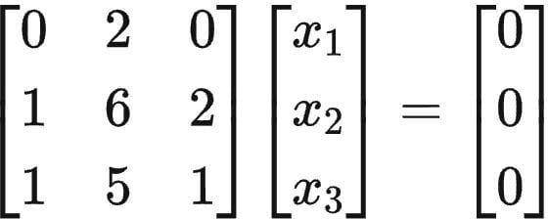To 1nd the null space of matrix A , we need to solve the homogeneous equation ( Ax =0. Setting up the equation Ax = 0 and solving for x, we get:

This leads to the system of equations:

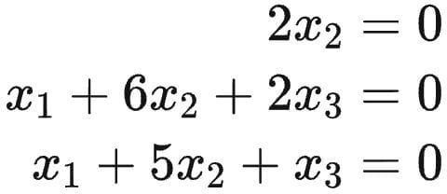

Solving this system of equations, we 1nd that x² = 0 , x¹ = -2x³, and x³ is a free variable. Therefore, the null space of matrix A is given by:

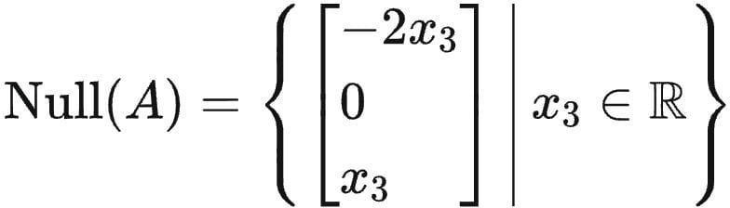

The dimension of the null space , din (Null (A), is 1 since there is only one free variable.

Step 3: Verify the equation n = rank (A) + dim (Null (A)). The given matrix A has 3 columns, so n = 3 .

We found that the rank of matrix A is 3 and the dimension of the null space is 1. Therefore, 3 = 3 + 1 , which is true.

Hence, we have proved that n =

Question 2 ❓

Solution.

To determine whether the signals 3^k,(-5)^k،

0^k are linearly independent or not, we can analyze the linear combination of these signals. Let's consider a linear combination:

c¹ 3k + c² (-5)^k + c³ 0^k = 0 Now, let's simplify this expression: c¹.3^k + c² (-5) k = 0

Since 0k is always 0, we can exclude the third term.

Now, let's evaluate the equation for diIerent values of k to see if there exist coe cients c¹, c², c³ where at least one of them is non-zero) that satisfy the equation for all k.

For k = 1:

c¹.3 + c².(-5) = 0

For k = 2:

c¹. 3² + c². (-5)²= 0

Continue this pattern for a few values of k to check if there exists a non-trivial solution (i.e., not all coe cients are zero).

If, after checking multiple values of k, the only solution is c¹ = c² = 0, then the signals are linearly independent. If there exists a non-trivial solution, then the signals are linearly dependent.

Note: The key observation here is that 0^k is always 0, so it does not contribute to the linear independence of the signals.